Homework 8

Jacob Taylor Cassady

Semiconductor Development Fundamentals

March 20, 2020

## *Note: I tried to copy and paste code in as it was relevant. I also copied the entire source code at the very end.*

# Consider a Germanium p-n junction with 𝑁𝐴 = 1015 cm-3 and 𝑁𝐷 = 1015 cm-3 . The minority carrier lifetime on the p-side is 50 μs, and the minority carrier lifetime on the nside is 50 μs

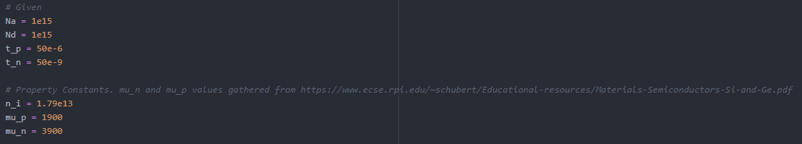

## What is the built-in voltage, 𝑉𝑏𝑖?





0.208389 [V]

## What is the excess electron concentration at 𝑥 = −𝑥𝑝, for 𝑉𝑎𝑝𝑝 = −3 𝑉?



-320,410,000,000 [cm ^ -3]

## What is the excess electron concentration at 𝑥 = −𝑥𝑝, for 𝑉𝑎𝑝𝑝 = 0.5 𝑉?

7.75835e+19 [cm ^ -3]

## What is the reverse saturation current density, 𝐽s?







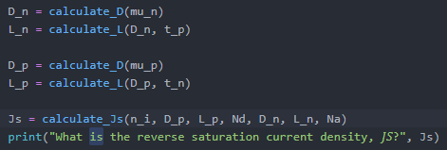

0.001681168 [A / cm^2]

## What is the current density for 𝑉𝑎𝑝𝑝 = −3 𝑉?



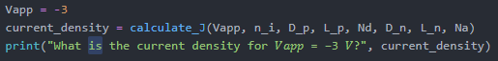

-0.001681168 [A / cm^2]

## What is the current density for 𝑉𝑎𝑝𝑝 = 0.5 𝑉?



407075.0774 [A / cm^2]

### *For the following problems, assume:*

### *The cross-sectional area is 250 μm x 250 μm.*

### *The minority carrier lifetime on the p-side is 100 ns.*

### *The minority carrier lifetime on the n-side is 10 μs*

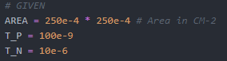

# Consider a Si p-n junction with 𝑁𝐴 = 1018 cm-3 and 𝑁𝐷 = 1017 cm-3 .

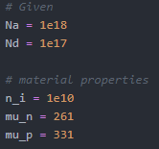

## What is the reverse saturation current, 𝐼s?

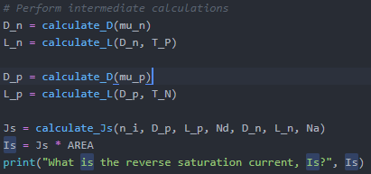

1.748085672905745e-16 [A]

## What is the current for 𝑉𝑎𝑝𝑝 = 0.5 𝑉 ?

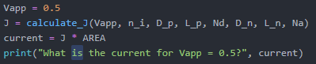

4.2327836289216224e-08 [A]

## Using a computer, plot the current versus applied voltage, ranging from -1 V to 0.8 V. Turn in your code.

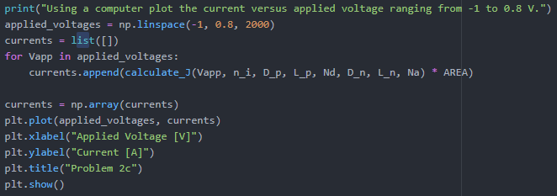

## What is the apparent turn-on voltage?

Approximately 0.75 [V]0

# Consider a GaN p-n junction with 𝑁𝐴 = 1018 cm-3 and 𝑁𝐷 = 1017 cm-3 .

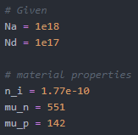

## What is the reverse saturation current, 𝐼s?

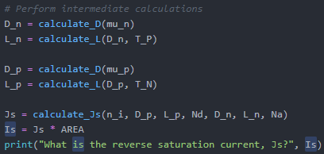

5.6425327326520155e-56 [A]

## Using a computer, plot the current versus applied voltage, ranging from -1 V to 0.8 V. Turn in your code.

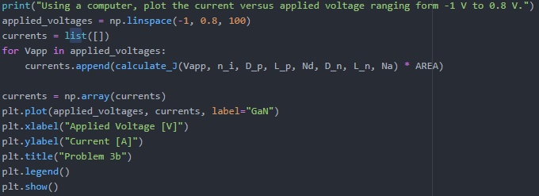

## What is the apparent turn-on voltage?

0.75 [V]

## Compare this graph with the graph from problem #2. For the same voltage, which diode has greater current: the silicon diode or the GaN diode?

The silicon diode has a much greater current than the GaN diode.

## Change the x-axis so that the forward current is similar to that found for the silicon diode. Superimpose the graphs for the silicon diode and the GaN diode. Make a single, nice graph. Turn in your code.

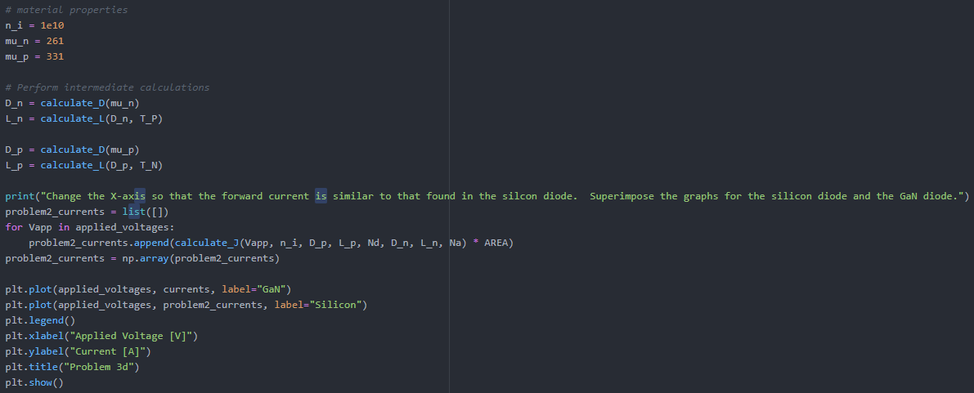

## What is the apparent turn-on voltage for the silicon diode and the GaN diode?

0.75 [V]

# Consider a Si p-n junction with 𝑁𝐴 = 1018 cm-3 and 𝑁𝐷 = 1017 cm-3 . The length of the n-region is 200 μm, and the length of the p- region is 20 μm. What are:

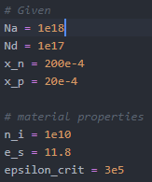

## The breakdown voltage considering only avalanche breakdown?





4.126817683628187 [V]

## The breakdown voltage considering only punch-through on the n-side?





3369155.246689906 [V]

## The breakdown voltage considering only punch-through on the p-side?





3369155.246689906 [V]

## The overall breakdown voltage?



6738314.620197495 [V]

import math

import numpy as np

import matplotlib.pyplot as plt

KBT_Q = 0.0259

q = 1.6e-19

e_0 = 8.854e-14

def calculate_excess_electron_concentration(n_i, Na, Vapp):

return n_i**2 / Na * (math.exp(Vapp / KBT_Q) - 1)

def calculate_built_in_voltage(n_i, Nd, Na):

return KBT_Q*math.log(Na * Nd / n_i**2)

def calculate_Js(n_i, D_p, L_p, Nd, D_n, L_n, Na):

return q * n_i**2 * ((D_p / (L_p * Nd)) + (D_n / (L_n * Na)))

def calculate_J(Vapp, n_i, D_p, L_p, Nd, D_n, L_n, Na):

Js = calculate_Js(n_i, D_p, L_p, Nd, D_n, L_n, Na)

return Js * (math.exp(Vapp/KBT_Q) - 1)

def calculate_D(mu):

return KBT_Q * mu

def calculate_L(D, t):

return (D * t)**0.5

def calculate_avalanche_breakdown(n_i, Nd, Na, e_s, epsilon_crit):

Vbi = calculate_built_in_voltage(n_i, Nd, Na)

return epsilon_crit**2 * (e_s * e_0 / (2 * q)) * ((Nd + Na)/(Na*Nd)) + Vbi

def calculate_punch_through_n(n_i, Nd, Na, e_s, x_n):

Vbi = calculate_built_in_voltage(n_i, Nd, Na)

return q * Nd / (2 * e_s * e_0) * ((Na + Nd) / Na) * x_n**2 - Vbi

def calculate_punch_through_p(n_i, Nd, Na, e_s, x_p):

Vbi = calculate_built_in_voltage(n_i, Nd, Na)

return q * Na / (2 * e_s * e_0) * ((Nd + Na) / Nd) * x_p**2 - Vbi

def problem_1():

print("\nProblem 1")

print("Consider a Germanium p-n junction with NA = 1015 cm-3 and ND = 1015 cm-3. The minority carrier lifetime on the p-side is 50 micro-s, and the minority carrier lifetime on the nside is 50 micro-s.")

# Given

Na = 1e15

Nd = 1e15

t_p = 50e-6

t_n = 50e-9

# Property Constants. mu_n and mu_p values gathered from https://www.ecse.rpi.edu/~schubert/Educational-resources/Materials-Semiconductors-Si-and-Ge.pdf

n_i = 1.79e13

mu_p = 1900

mu_n = 3900

Vbi = calculate_built_in_voltage(n_i, Nd, Na)

print("What is the built-in voltage, 𝑉𝑏𝑖?", Vbi)

Vapp = -3

excess_electron_concentration = calculate_excess_electron_concentration(n_i, Na, Vapp)

print("What is the excess electron concentration at 𝑥 = −xp, for Vapp = −3 𝑉?", excess_electron_concentration)

Vapp = 0.5

excess_electron_concentration = calculate_excess_electron_concentration(n_i, Na, Vapp)

print("What is the excess electron concentration at 𝑥 = −xp, for Vapp = 0.5 𝑉?", excess_electron_concentration)

D_n = calculate_D(mu_n)

L_n = calculate_L(D_n, t_p)

D_p = calculate_D(mu_p)

L_p = calculate_L(D_p, t_n)

Js = calculate_Js(n_i, D_p, L_p, Nd, D_n, L_n, Na)

print("What is the reverse saturation current density, 𝐽𝑆?", Js)

Vapp = -3

current_density = calculate_J(Vapp, n_i, D_p, L_p, Nd, D_n, L_n, Na)

print("What is the current density for 𝑉𝑎𝑝𝑝 = −3 𝑉?", current_density)

Vapp = 0.5

current_density = calculate_J(Vapp, n_i, D_p, L_p, Nd, D_n, L_n, Na)

print("What is the current density for 𝑉𝑎𝑝𝑝 = 0.5 𝑉?", current_density)

# GIVEN

AREA = 250e-4 * 250e-4 # Area in CM-2

T_P = 100e-9

T_N = 10e-6

def problem_2():

print("\nProblem 2:")

print("Consider a Si p-n junction with 𝑁𝐴 = 1018 cm-3 and 𝑁𝐷 = 1017 cm-3")

# Given

Na = 1e18

Nd = 1e17

# material properties

n_i = 1e10

mu_n = 261

mu_p = 331

# Perform intermediate calculations

D_n = calculate_D(mu_n)

L_n = calculate_L(D_n, T_P)

D_p = calculate_D(mu_p)

L_p = calculate_L(D_p, T_N)

Js = calculate_Js(n_i, D_p, L_p, Nd, D_n, L_n, Na)

Is = Js * AREA

print("What is the reverse saturation current, Is?", Is)

Vapp = 0.5

J = calculate_J(Vapp, n_i, D_p, L_p, Nd, D_n, L_n, Na)

current = J * AREA

print("What is the current for Vapp = 0.5?", current)

print("Using a computer plot the current versus applied voltage ranging from -1 to 0.8 V.")

applied_voltages = np.linspace(-1, 0.8, 2000)

currents = list([])

for Vapp in applied_voltages:

currents.append(calculate_J(Vapp, n_i, D_p, L_p, Nd, D_n, L_n, Na) * AREA)

currents = np.array(currents)

plt.plot(applied_voltages, currents)

plt.xlabel("Applied Voltage [V]")

plt.ylabel("Current [A]")

plt.title("Problem 2c")

plt.show()

print("What is the apprent turn-on voltage?")

print("Approximately 0.75V")

def problem_3():

print("\nProblem 3:")

print("Consider a GaN p-n junction with Na = 1018 cm-3 and Nd = 1017 cm-3")

# Given

Na = 1e18

Nd = 1e17

# material properties

n_i = 1.77e-10

mu_n = 551

mu_p = 142

# Perform intermediate calculations

D_n = calculate_D(mu_n)

L_n = calculate_L(D_n, T_P)

D_p = calculate_D(mu_p)

L_p = calculate_L(D_p, T_N)

Js = calculate_Js(n_i, D_p, L_p, Nd, D_n, L_n, Na)

Is = Js * AREA

print("What is the reverse saturation current, Js?", Is)

print("Using a computer, plot the current versus applied voltage ranging form -1 V to 0.8 V.")

applied_voltages = np.linspace(-1, 0.8, 100)

currents = list([])

for Vapp in applied_voltages:

currents.append(calculate_J(Vapp, n_i, D_p, L_p, Nd, D_n, L_n, Na) * AREA)

currents = np.array(currents)

plt.plot(applied_voltages, currents, label="GaN")

plt.xlabel("Applied Voltage [V]")

plt.ylabel("Current [A]")

plt.title("Problem 3b")

plt.legend()

plt.show()

print("What is the apparent turn-on voltage?")

print("Approximately 0.75V")

# material properties

n_i = 1e10

mu_n = 261

mu_p = 331

# Perform intermediate calculations

D_n = calculate_D(mu_n)

L_n = calculate_L(D_n, T_P)

D_p = calculate_D(mu_p)

L_p = calculate_L(D_p, T_N)

print("Change the X-axis so that the forward current is similar to that found in the silcon diode. Superimpose the graphs for the silicon diode and the GaN diode.")

problem2_currents = list([])

for Vapp in applied_voltages:

problem2_currents.append(calculate_J(Vapp, n_i, D_p, L_p, Nd, D_n, L_n, Na) * AREA)

problem2_currents = np.array(problem2_currents)

plt.plot(applied_voltages, currents, label="GaN")

plt.plot(applied_voltages, problem2_currents, label="Silicon")

plt.legend()

plt.xlabel("Applied Voltage [V]")

plt.ylabel("Current [A]")

plt.title("Problem 3d")

plt.show()

print("What is the apparent turn-on voltage for the silicon diode and the GaN diode?")

print("Approximately 0.75V")

def problem_4():

print("\nProblem 4:")

print("Consider a Si p-n junction with 𝑁𝐴 = 1018 cm-3 and 𝑁𝐷 = 1017 cm-3 . The length of the n-region is 200 micro-m, and the length of the p- region is 20 micro-m. ")

# Given

Na = 1e18

Nd = 1e17

x_n = 200e-4

x_p = 20e-4

# material properties

n_i = 1e10

e_s = 11.8

epsilon_crit = 3e5

Vbr_avalanche = calculate_avalanche_breakdown(n_i, Nd, Na, e_s, epsilon_crit)

print("What is the breakdown voltage considering only avalanche breakdown?", Vbr_avalanche)

Vbr_punch_through_n = calculate_punch_through_n(n_i, Nd, Na, e_s, x_n)

print("What is the breakdown voltage considering only punch-through on the n-side?", Vbr_punch_through_n)

Vbr_punch_through_p = calculate_punch_through_p(n_i, Nd, Na, e_s, x_p)

print("What is the breakdown voltage considering only punch-through on the p-side?", Vbr_punch_through_p)

print("What is the overall breakdown voltage?", Vbr_avalanche + Vbr_punch_through_n + Vbr_punch_through_p)

if __name__ == "__main__":

problem_1()

problem_2()

problem_3()

problem_4()